Corporate Financial Performance & Sustainability Metrics
An analysis of the relationship between ESG scores, profitability, and environmental impact (2015–2025)
Prepared by: Lütfi Barkın Yılgör
Student ID: 32481
Project Overview
In this project, I analyze how companies’ ESG (Environmental, Social, and Governance) performance relates to their financial results and environmental impact.
In my previous study, “ESG, CSR, and Sustainability Practices Around the World,” our group explored sustainability and corporate responsibility from a theoretical perspective.
Now, I am taking the next step individually — using data science to examine how these ideas translate into real corporate performance outcomes.
Here, ESG scores serve as indicators of how responsibly, efficiently, and transparently companies operate across environmental, social, and governance dimensions.
Using a dataset of 1,000 global companies from 2015 to 2025, this project examines whether companies that demonstrate stronger sustainability performance also perform better financially and reduce their environmental footprint over time.
Motivation
Sustainability has become a global business priority — yet there’s still debate over whether it’s profitable or simply a moral responsibility.
After studying the theory behind ESG and CSR, I wanted to explore the data side:
Do companies that focus on being environmentally and socially responsible perform better financially?
Do they also show lower environmental impact?
Does this relationship differ across industries and regions?
By combining sustainability metrics with financial performance data, the goal is to uncover patterns that show how ethics and profitability can coexist.
Data Sources
Corporate ESG & Financial Performance Dataset (2015–2025)
Source: Kaggle
https://www.kaggle.com/datasets/shriyashjagtap/esg-and-financial-performance-dataset
Category | Columns
Financials | Revenue, ProfitMargin, MarketCap, GrowthRate
ESG Scores | ESG_Overall, ESG_Environmental, ESG_Social, ESG_Governance
Environmental Impact | CarbonEmissions, WaterUsage, EnergyConsumption
Context | Industry, Region, Year

Additional Context Dataset: Regional GDP (2015–2025)
Source: IMF World Economic Outlook (WEO)
https://www.imf.org/en/Publications/WEO/weo-database/2025/april/select-country-group
Role of GDP in This Project:
GDP will be used as a contextual comparison, to examine whether regions with higher GDP also tend to show higher ESG performance and higher ProfitMargin.
Tools & Technologies
Python
Pandas & NumPy — data processing
Matplotlib & Seaborn — data visualization
Statsmodels / SciPy — statistical analysis
Scikit-Learn — regression & clustering
Research Hypothesis
H0 (Null Hypothesis): ESG performance has no meaningful relationship with financial or environmental outcomes.
H1 (Alternative Hypothesis): Companies with higher ESG performance tend to exhibit better financial performance and lower environmental impact.

Data Analysis
1. Data Preprocessing & Cleaning
Data Quality: Duplicate records were checked and removed. Rows with missing values in critical target variables (Revenue, ProfitMargin, ESG_Overall) were dropped.
Imputation: Missing GrowthRate values were filled using industry-specific medians.
GDP Processing: IMF GDP data was transformed from wide to long format and cleaned for numeric consistency.

Regional Aggregation Strategy:
Step A (Mapping): 196 countries were mapped into 7 ESG regions.
Step B (Aggregation): GDP values were summed by Region and Year.
Step C (Merge): ESG and GDP datasets were merged using Region and Year keys.
2. Summary Statistics
Completeness Verification:
After preprocessing and merging, zero missing values remained in key modeling variables.
Industry Baselines:
Significant profitability differences exist across industries, with Technology showing the highest average margins and Transportation the lowest.
Regional Economic Context:
Developed regions (North America, Europe) exhibit higher average GDP and ESG scores.
Variable Distributions:
ESG scores span the full 0–100 range, while ProfitMargin shows clustering patterns used later in clustering analysis.

3. Visualization
Four high-impact figures were analyzed, supported by a correlation matrix:
- Scatter plot of ESG Score vs. Profit Margin (by Region)
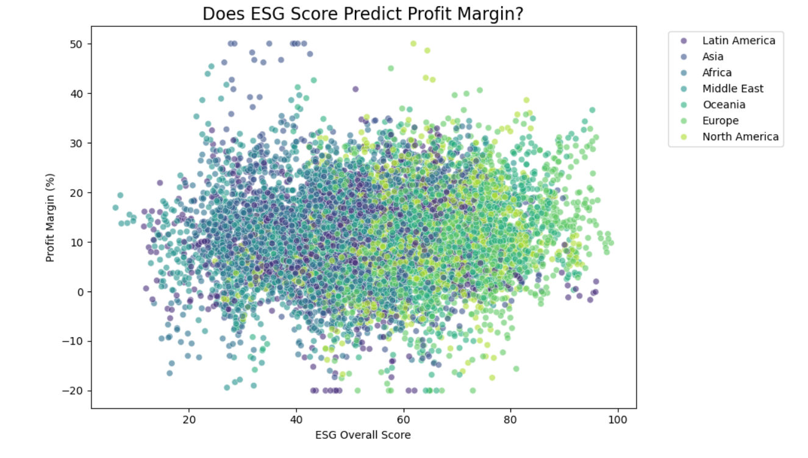

- Three-panel dashboard showing ESG vs Carbon, Water, and Energy intensity
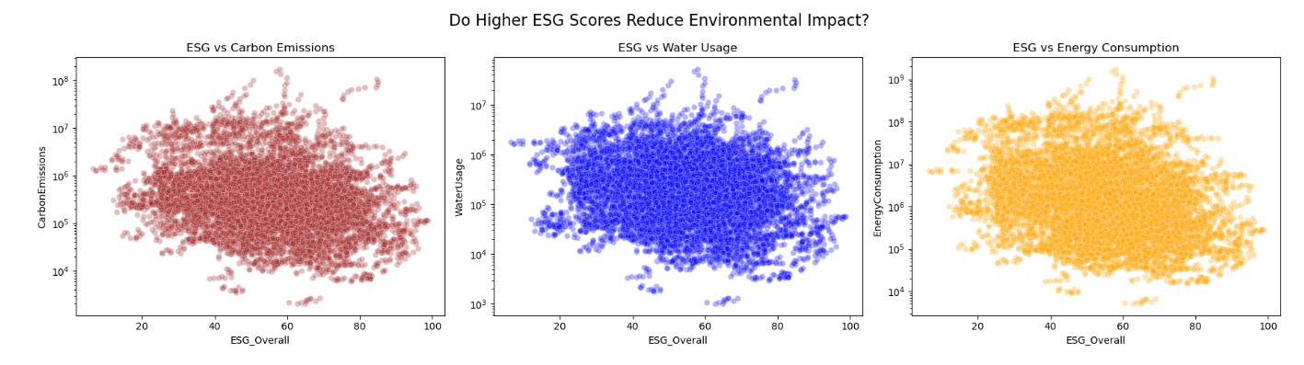

- Scatter plot of Average Regional GDP vs Average ESG Score
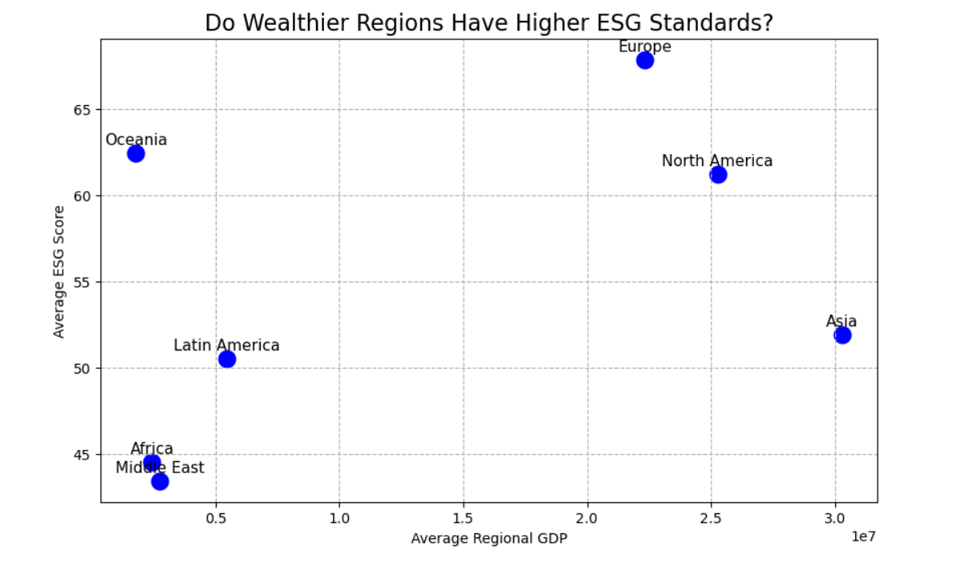

- Boxplot of Profit Margin by Industry

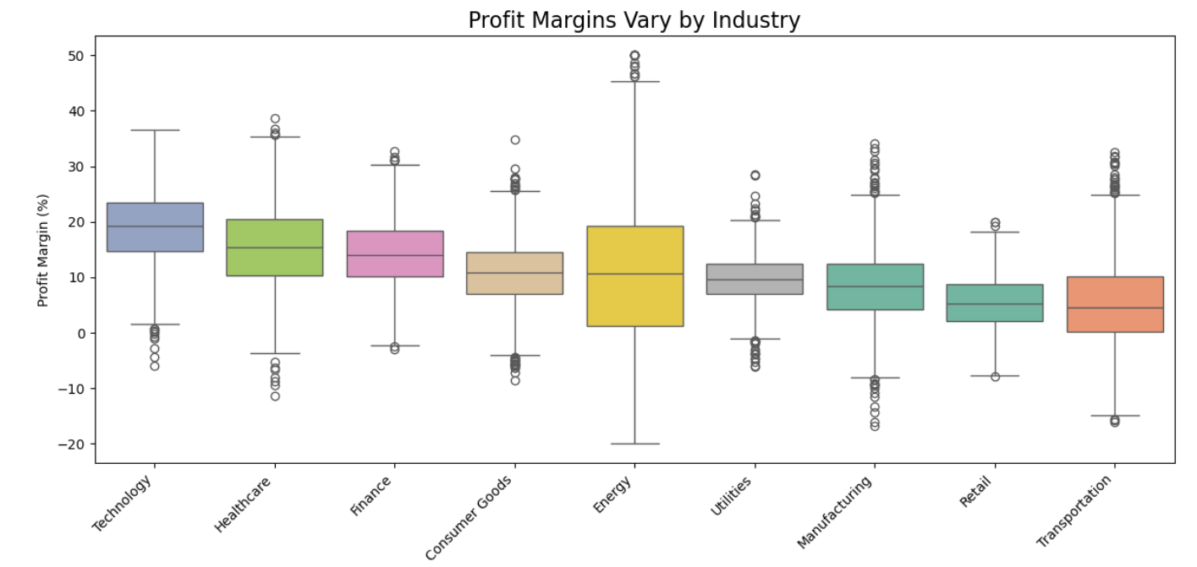

- Correlation matrix summarizing linear relationships between ESG, financial, environmental, and GDP metrics.
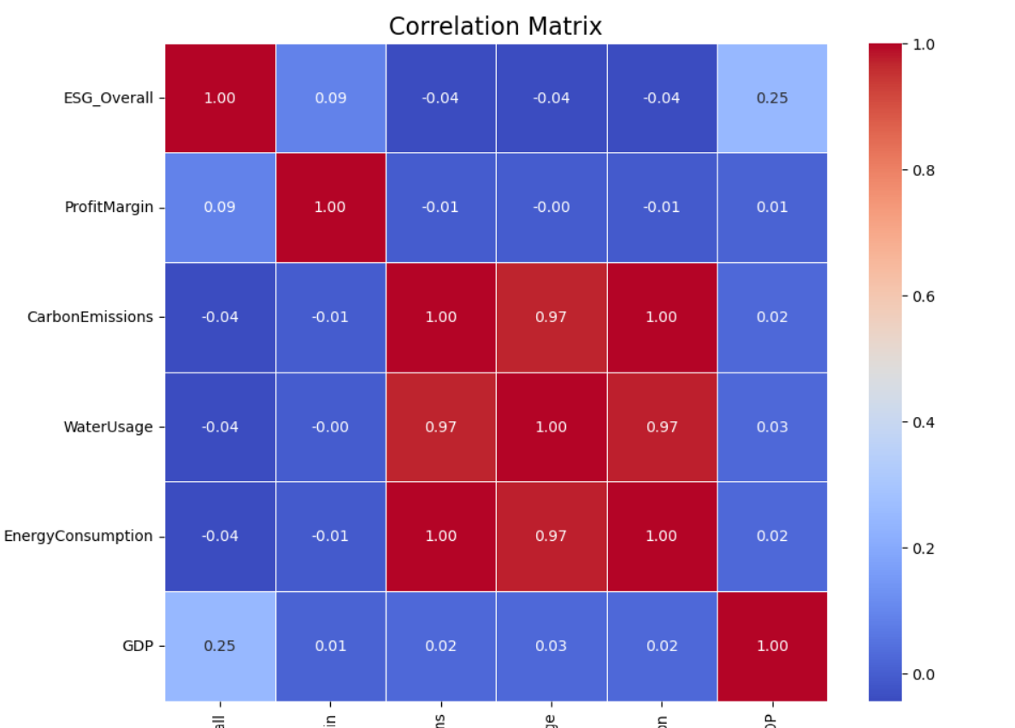
4. Statistical Inference (Hypothesis Testing)
Table 1 below reports hypothesis tests examining the relationship between ESG performance and key financial, environmental, and economic variables. Pearson correlation tests were used for firm-level outcomes (ProfitMargin, CarbonEmissions, WaterUsage, EnergyConsumption), while an Independent T-Test compared ESG scores across high- and low-GDP regions.
A 5% significance level (α = 0.05) was applied. In all cases, p-values below 0.05 lead to rejection of the null hypothesis (H₀), indicating statistically significant relationships. The results show a weak but positive association between ESG and profitability, negative associations between ESG and environmental impact metrics, and significantly higher ESG scores in wealthier regions. Although statistically significant, the small correlation coefficients indicate that ESG is one of several factors influencing corporate performance.

Table 1. Statistical Relationships Between ESG and Key Outcomes
Test | Target Variable | Statistic | P-value | Conclusion
Pearson Correlation | ProfitMargin | r = 0.0880 | 2.31e-20 | Reject H0
Pearson Correlation | CarbonEmissions | r = -0.0397 | 3.15e-05 | Reject H0
Pearson Correlation | WaterUsage | r = -0.0429 | 6.73e-06 | Reject H0
Pearson Correlation | EnergyConsumption | r = -0.0436 | 4.66e-06 | Reject H0
Independent T-Test | ESG by GDP Level | t = 30.39 | 7.44e-195 | Reject H0

Overall Summary
The results confirm that higher ESG performance is associated with improved environmental efficiency and modestly higher profitability.
ESG–profitability relationships differ across industries and regions.
Sustainability alignment is stronger in wealthier economies.
Machine Learning Applications
1. Predictive Modeling (Regression)
Goal: Determine whether ESG and environmental indicators explain ProfitMargin.
Feature Engineering:
- Applied Z-score standardization (StandardScaler) to all input features before training the Linear Regression model.
- Reasoning: Standardization ensures that variables measured on different scales (e.g., ESG scores, environmental quantities, and GDP) contribute proportionally to the model and allows regression coefficients to be interpreted more reliably.
- This step is particularly important for linear models, which are sensitive to feature scale, while tree-based models (Random Forest) were trained on the original (unscaled) data, as they are scale-invariant.
Features used: ESG_Overall, CarbonEmissions, WaterUsage, EnergyConsumption, GDP
Target: ProfitMargin
Models:
- Dummy Regressor — establishes a baseline (predicting the mean)
- Multiple Linear Regression — tests for linear relationships
- Random Forest Regressor — captures non-linear effects
Evaluation metrics:
- R²
- RMSE
- Feature importance (to identify which predictors matter most for ProfitMargin)
Table 2. Predictive Model Performance (ProfitMargin)
Model | RMSE | R² Score
Baseline (Mean) | 8.9234 | -0.0002
Linear Regression | 8.9303 | -0.0017
Random Forest | 6.7360 | 0.4301

Interpretation:
- The baseline model performs essentially at chance level (R² ≈ 0), showing that predicting the mean provides no explanatory value.
- Multiple Linear Regression does not improve upon the baseline (negative R²), indicating that the relationship between ESG/environmental indicators and ProfitMargin is not well-captured by a purely linear specification.
- The Random Forest Regressor substantially improves performance (R² ≈ 0.43 and lower RMSE), suggesting that non-linear interactions and threshold effects are important in explaining ProfitMargin.
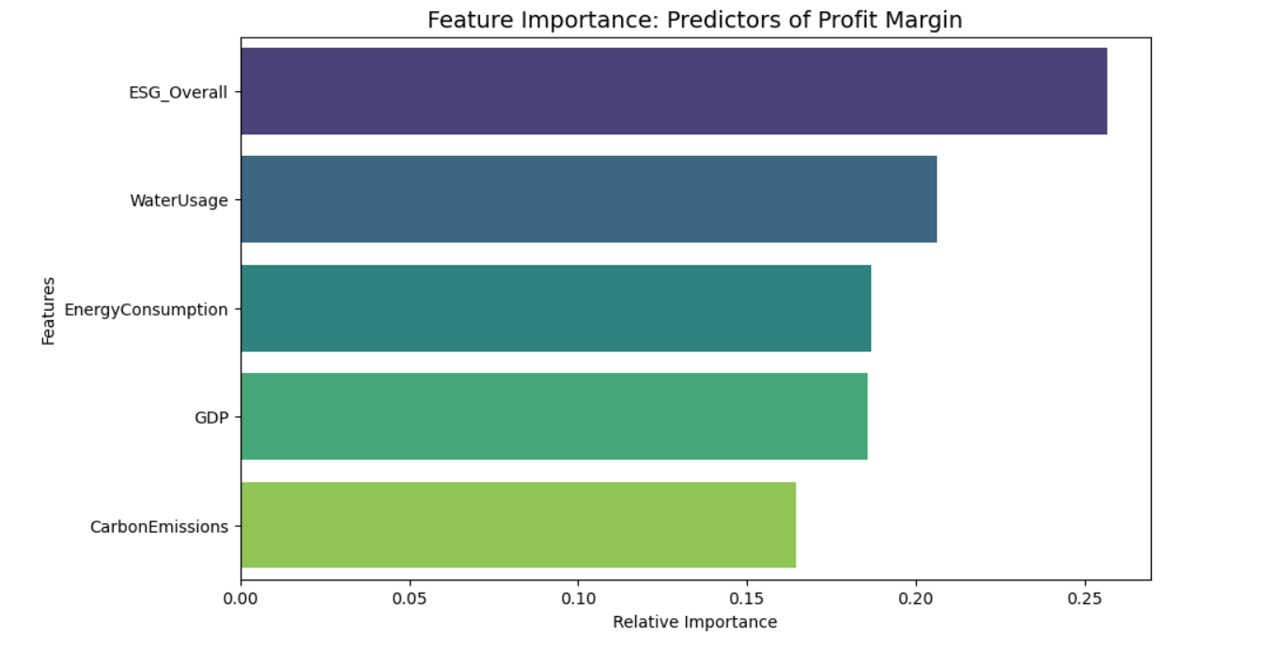

2. Clustering Analysis (Sustainability Profiles)
Goal: Identify sustainability-performance groups among companies.
Feature Engineering:
- Applied Z-score standardization (StandardScaler) to ESG_Overall and ProfitMargin.
- Reasoning: This normalization ensures that the large numerical difference between ESG scores (0–100) and profit percentages (0–1) does not bias the K-Means clustering distances.
Method:
- K-Means Clustering on the standardized features
- Optimal k explored using:
- Elbow Method (Inertia)
- Silhouette Score
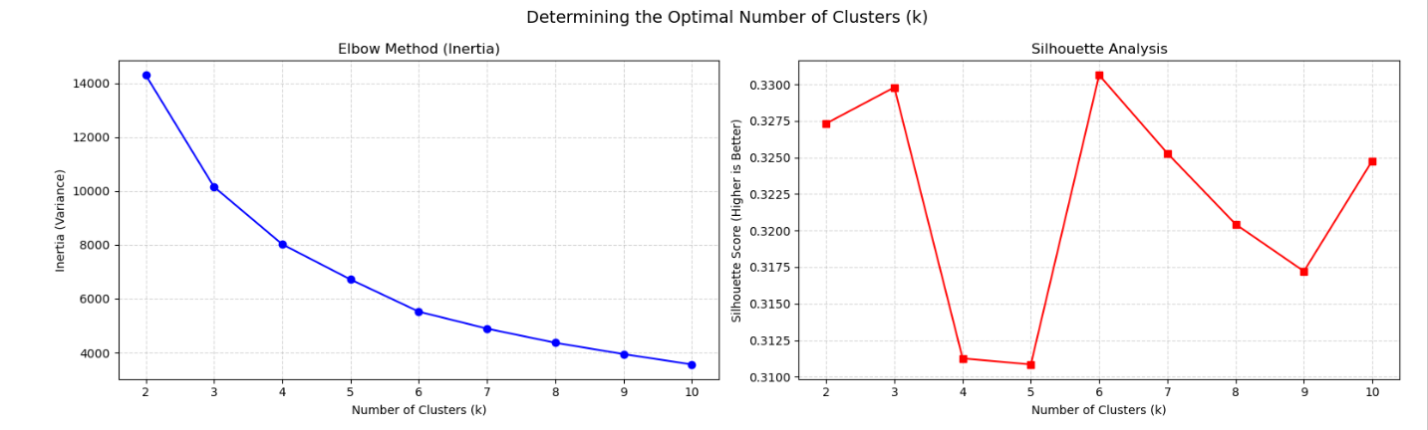
Table 3. Sustainability–Profitability Cluster Profiles
Cluster | Average ESG Score | Average Profit Margin (%)
0 | 38.91 | 8.59
1 | 65.12 | 5.15
2 | 61.19 | 20.45

Interpretation:
- Cluster 0 represents a low-ESG, moderate-profit profile.
- Cluster 1 represents a high-ESG, low-profit profile.
- Cluster 2 represents a high-ESG, high-profit profile.
These profiles highlight that “high ESG” does not imply a single profitability outcome; instead, firms appear to adopt different sustainability strategies with heterogeneous financial performance.

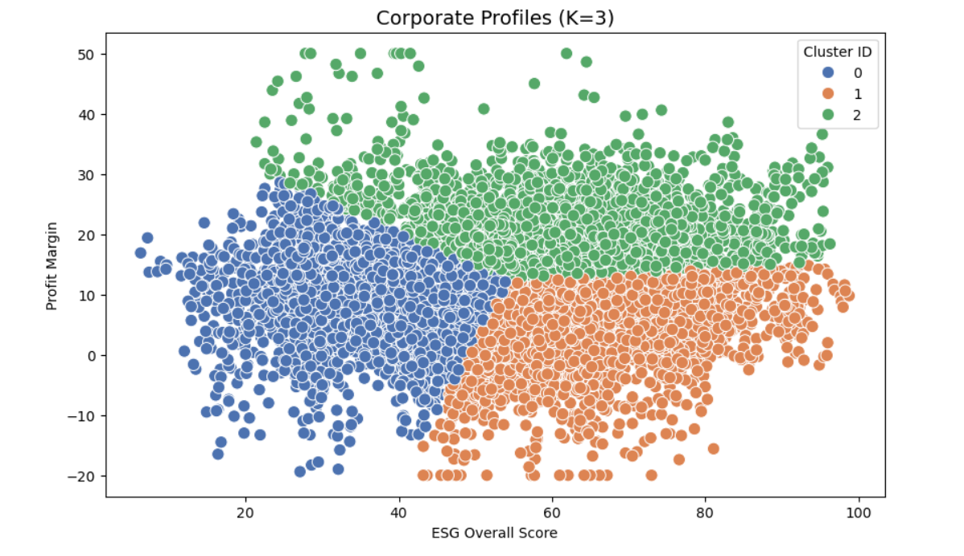
Overall ML Summary:
The machine learning results reinforce the broader project conclusion: ESG and environmental variables are informative, but their relationship with profitability is complex. Linear models fail to capture the structure, while non-linear models (Random Forest) provide meaningful predictive power. Clustering further reveals distinct sustainability–performance profiles, suggesting strategic heterogeneity rather than a universal ESG-profit trade-off.
Expected Outcomes
Higher ESG scores may correspond to lower emissions and higher operational efficiency.
ESG–profitability patterns may differ across industries and regions.
GDP comparisons may reveal whether sustainability alignment is stronger in economically developed regions.
Clustering analysis may uncover distinct corporate sustainability strategies.

Limitations and Future Work
Limitations
- Synthetic Data: The Corporate ESG & Financial Performance Dataset is simulated, meaning observed relationships may appear cleaner and more distinct than in real-world data.
- Regional Aggregation: Grouping countries into broad regions (e.g., Europe) masks country-specific economic and regulatory differences.
- No Causality: While strong correlations are observed, the analysis cannot establish causal relationships between ESG performance and profitability.
- Non-Linear Relationships: Simple linear models fail (R² < 0), indicating that standard linear formulations cannot adequately capture these dynamics.
Future Work
- Granular Analysis: Incorporate country-level data to capture more precise economic and regulatory effects.
- Time-Series Forecasting: Apply advanced models such as ARIMA or LSTM to forecast future ESG and financial performance trends.
- Industry-Specific Models: Develop separate machine learning models for distinct sectors (e.g., Technology vs Energy) to improve predictive accuracy.

Key Findings
Based on the visualizations, statistical tests, predictive modeling, and clustering results, the following key findings summarize the core insights of the project:
- ESG performance is statistically linked to both profitability and efficiency. ESG_Overall shows a weak but significant positive correlation with ProfitMargin, and small but significant negative correlations with CarbonEmissions, WaterUsage, and EnergyConsumption—supporting the idea that higher ESG aligns with lower environmental footprint.
- Economic maturity strengthens sustainability alignment. High-GDP regions have significantly higher ESG scores (t-test p ≈ 0), indicating that wealthier economies tend to support stronger sustainability performance as a baseline context factor.
- ESG–profitability relationships are not one-size-fits-all. Profit margins differ substantially across industries, so ESG effects should be interpreted with sector context rather than assuming a uniform global relationship.
- Profitability is better explained by non-linear interactions than linear formulas. Linear regression fails to outperform a baseline predictor (negative R²), while Random Forest provides meaningful predictive power (R² ≈ 0.43), implying that ESG and environmental variables influence profitability through complex, non-linear dynamics.
- Companies separate into distinct sustainability–profitability profiles. Clustering reveals multiple strategic patterns (e.g., high-ESG/high-profit and high-ESG/low-profit groups), suggesting that high ESG can coexist with different profitability outcomes depending on business model, efficiency, and operating context.
Overall, ESG appears not only ethically relevant but also structurally embedded in corporate performance dynamics. When sustainability metrics are analyzed jointly with environmental and contextual variables—and modeled with flexible methods—ESG emerges as a meaningful indicator of operational efficiency and long-term corporate resilience, especially in developed economies.

